

**Assignment on CSE 224**

**Topic : P-type Semiconductor**

**Submitted by: Submitted to:**

**P-type Semiconductor**

We know semiconductors are a special class of elements having a conductivity between a good conductor and an insulator. There are two types of semicondutor one is p-type another is n-type.

p-type is an extrinsic semiconductor which is obtained by doping trivalent impurity atoms such as boron, galium etc to the pure germenium or silicon semiconductor.

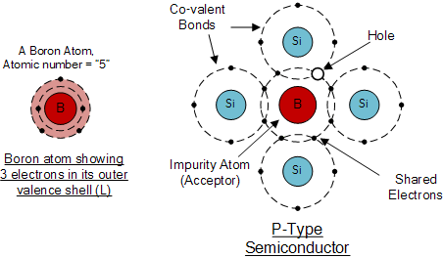

In p-type semiconductor the iumpurity added, create vacancies of electrons in this structure are called accepted atoms. The holes are majority charge carrier and electrons are minority carrier.

**Use of P-type semiconductors:**

Extrinsic semiconductors ( p-type & n-type) are components of many common electrical devices. A semiconductor diode (devices that allow current in only one direction) consists of p-type and n-type semiconductors placed in junction with one another.

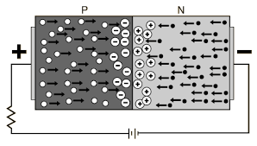

Currently, most semiconductor diodes use doped silicon or germanium.Transistors (devices that enable current switching) also make use of extrinsic semiconductors. Bipolar junction transistors (BJT), which amplify current, are one type of transistor. The most common BJTs are NPN and PNP type. NPN transistors have two layers of n-type semiconductors sandwiching a p-type semiconductor. PNP transistors have two layers of p-type semiconductors sandwiching an n-type semiconductor.

Field-effect transistors (FET) are another type of transistor which amplify current implementing extrinsic semiconductors. As opposed to BJTs, they are called unipolar because they involve single carrier type operation - either N-channel or P-channel. FETs are broken into two families, junction gate FET (JFET), which are three terminal semiconductors, and insulated gate FET (IGFET), which are four terminal semiconductors.

So, after all we can say that P-type semiconductor is so much important because of it’s charecteristics. In every sector of electronics iit is needed.